Characteristic functional of physical thermal noise,
including equilibrium quantum 1/f noise

Peter H. Handel ¹ and Thomas F. George ²

¹ Department of Physics & Astronomy, University of Missouri-St. Louis
St. Louis, MO 63121, USA

² Office of the Chancellor / Departments of Physics & Astronomy and Chemistry & Biochemistry
University of Missouri-St. Louis, St. Louis, MO 63121, USA

I. Introduction
In a previous paper [1], the characteristic functional of quantum 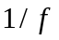 noise was derived. The result is applicable to quantum noise in any cross section or process rate, and in currents and voltages. In another paper [2], the application of quantum noise to thermal equilibrium noise was carried out, and the quantum Nyquist theorem was developed. Deviations from the Gaussian form of thermal noise were expressed in terms of the characteristic function [2,3].
This present paper performs the final step in the study of thermal noise with infrared radiative corrections by calculating the characteristic functional of physical thermal noise. We call it “physical” because we refer to the actual observed thermal equilibrium (Johnson) noise, rather than to the strictly Gaussian noise expected from the Nyquist formula without infrared radiative corrections. The small quantum contributions come in as time-dependent infrared corrections as required by the interactions of the current carriers with the electromagnetic field, or by the reaction of the bremsstrahlung back on the current which has produced it. Knowing the characteristic functional of a process represents the highest level and most comprehensive description possible for a random process.

II. Amplitude distribution and characteristic function
In terms of current fluctuations in equilibrium, to derive the characteristic function of the physical thermal noise current variable , we express it in terms of the unmodulated theoretical Nyquist noise current variable x as
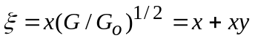 , (1)
where 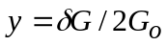 is the fractional quantum fluctuation in the conductivity 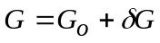 of the conductor whose thermal equilibrium current fluctuations we are considering. Let the quantum noise variable obey a Gaussian amplitude distribution of dispersion 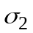, and one of dispersion 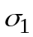. We prove now that in terms of the zeroth-order Bessel function of imaginary argument, the product 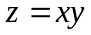 will have an amplitude distribution 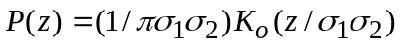 which has an elementary characteristic function
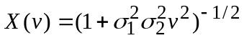 . (2)
In order to derive the amplitude distribution of , we introduce 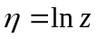, 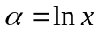 and 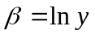. From 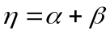, we obtain the distribution
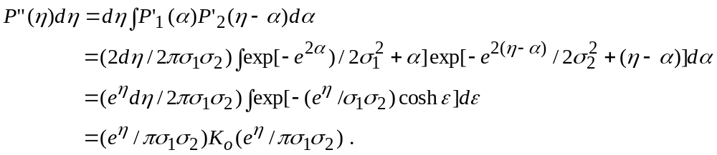 (3)
Here 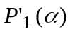 and 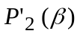 are derived from Gaussians of dispersion and , respectively, 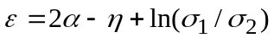, and 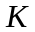 is the modified zeroth-order Bessel function. Returning to the real variable , we obtain from 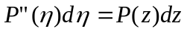
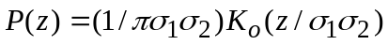 . (4)
A Fourier transform shows that the corresponding characteristic function is elementary:
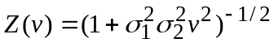 . (5)
This is just what we wanted to prove.
Our next step is the calculation of the characteristic function of . Due to the mutual dependence of and , the characteristic function of differs from the product of the characteristic functions of and . We obtain instead the amplitude probability density function (pdf)
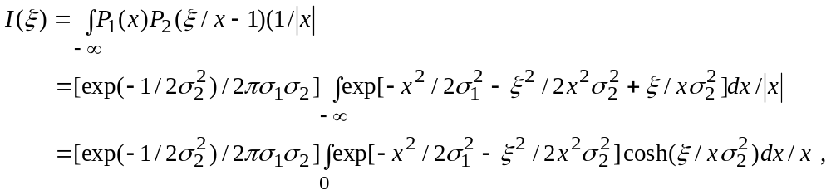 (6)
which we have written down directly, but which can also be obtained by substituting 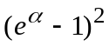 for 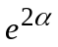 in Eq. (3). This distribution tends to a Gaussian in the limit 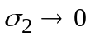, but differs slightly from a Gaussian in general. The skewness is zero, but the kurtosis exhibits a small deviation from the Gaussian amplitude pdf.
By performing a Fourier transform of Eq. (6), we find again that the characteristic function of the total physical thermal noise is elementary,
, (7)
while the amplitude distribution itself can not be expressed in terms of elementary functions. Here 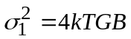 and 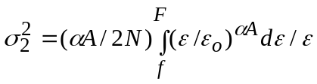, with 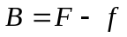 representing the bandwidth under consideration.
In the remaining portion of the paper, we derive the characteristic functional of thermal noise, including thermal equilibrium quantum noise in the conductance G. We first familiarize the reader with characteristic functionals in general.

III. Characteristic functionals
The complete characterization of a random process 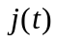 is given by its characteristic functional [4]
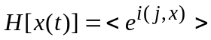 . (8)
In our case, 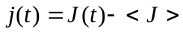 is the current (or voltage or fractional conductance) fluctuation; 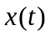 is the argument function of the functional; and the scalar product in Hilbert space is defined as
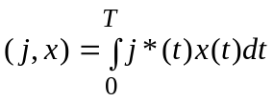 . (9)
Here 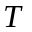 is the interval of observation of the fluctuations, i.e., the length of the sample considered from the stationary random process at hand. Particularly simple, the characteristic functional of a Gaussian process is [4]
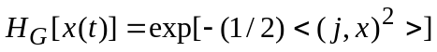 . (10)
For thermal short-circuit current fluctuations in a resistor of conductance  described by the simple Nyquist formula with 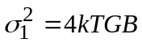, the characteristic functional is
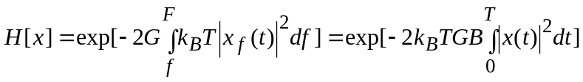 , (11)
where 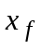 is the Fourier-transformed argument function. Here the two-sided frequency integral is limited to the allowed bandwidth B, and the time integral to the interval of observation. Since 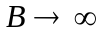, 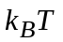 must be replaced by 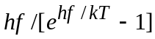 and included in the frequency integral, while the time integral must also include the Fourier-transformed Planck kernel.
The characteristic functional of quantum noise affecting the conductance has been shown to be [1]
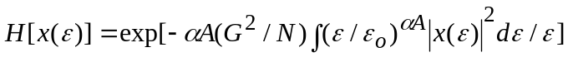 . (12)
Here 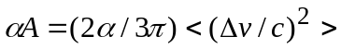 is the infrared exponent, which is known to enter the expression of both the basic quantum noise formula and the characteristic functional of quantum noise in two ways: as a coefficient and as an additional exponent of the frequency . Sommerfeld’s fine structure constant 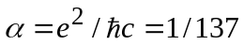 is well known, and is Boltzmann’s constant 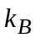. Equation (12) gives the characteristic functional of noise for a sample containing 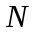 current carriers with an average velocity change 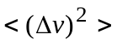 in the scattering processes which determine their mobility. Since we are interested in the variable 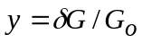, we must replace by 1/4 in Eq. (12).
For each value of the frequency, we now use Eqs. (11) and (12), repeating the steps which led to the derivation of Eq. (5). This yields the characteristic functional of the term in Eq. (1),
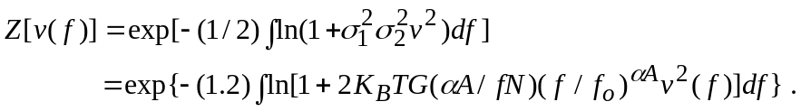 (13)
According to Eq. (1), we now have to add the Nyquist term . Repeating for every frequency the steps which led us to Eq. (7), we obtain now the characteristic functional of physical thermal noise 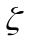 in the form
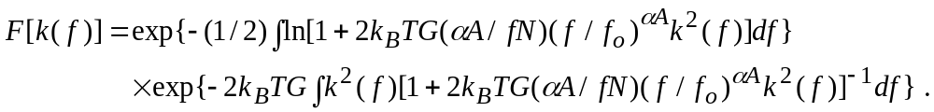 (14)
This equation gives the characteristic functional of physical thermal noise for a sample containing current carriers with an average velocity change in the scattering processes which determine their mobility, resulting in a well-defined infrared exponent 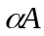.

References
[1] P. H. Handel and D. Wolf, Phys. Rev. A 26, 3727 (1982).
[2] P. H. Handel, C. M. Van Vliet and A. van der Ziel, in Proceedings of the 7th International Conference on Noise in Physical Systems and the 3rd International Conference on 1/f Noise, edited by M. Savelli, G. Lecoy and J. P. Nougier (North Holland, Amsterdam, 1983), p. 93 ff.
[3] P. H. Handel, D. Wolf and K. M. Van Vliet, in Proceedings of the 6th International Conference on Noise in Physical Systems, edited by P. H. E. Meijer, R. D. Mountain and R. J. Soulen, National Bureau of Standards Special Publication 614, 196 (1981).
[4] J. L. Lumley, Stochastic Tools in Turbulence (Academic, New York, 1970), p. 48.

